| | **Software Design Specifications**  **FASTransit**  **Version: [1.0]**   | Code | CS3009 | | --- | --- | | Supervisor | Rubab Jaffer | | Co Supervisor | - | | Project Team | Syed Uzair Hussain Zaidi - 22K4212  Basil Yaqoob - 22K4634 | | Submission Date | 6/5/2025 | | | --- | --- | --- | --- | --- | --- | --- | --- | --- | --- | --- |   **Document History**  [Revision history will be maintained to keep a track of changes done by anyone in the document.]   | Version | Name of Person | Date | Description of change | | --- | --- | --- | --- | | 1.0 | Basil Yaqoob | 4/5/2025 | Created SDS | | 1.0 | Syed Uzair Hussain | 5/5/2025 | Added Diagrams and Data Dictionary | | 1.0 | Syed Uzair Hussain | 6/5/2025 | Added ERD Diagram | |  |  |  |  | |  |  |  |  | |  |  |  |  | |  |  |  |  |         **Distribution List**  [Following table will contain list of people whom the document will be distributed after every sign-off]   | **Name** | **Role** | | --- | --- | | Rubab Jaffer | Supervisor | | - | Co Supervisor | |  |  |       **Document Sign-Off**   | **Version** | **Sign-off Authority** | **Project Role** | **Signature** | **Sign-off Date** | | --- | --- | --- | --- | --- | |  |  |  |  |  | |  |  |  |  |  | |  |  |  |  |  | |  |  |  |  |  | |  |  |  |  |  | |  |  |  |  |  | |  |  |  |  |  | |
| --- | --- | --- | --- | --- | --- | --- | --- | --- | --- | --- | --- | --- | --- | --- | --- | --- | --- | --- | --- | --- | --- | --- | --- | --- | --- | --- | --- | --- | --- | --- | --- | --- | --- | --- | --- | --- | --- | --- | --- | --- | --- | --- | --- | --- | --- | --- | --- | --- | --- | --- | --- | --- | --- | --- | --- | --- | --- | --- | --- | --- | --- | --- | --- | --- | --- | --- | --- | --- | --- | --- | --- | --- | --- | --- | --- | --- | --- | --- | --- | --- | --- | --- | --- | --- | --- | --- | --- | --- | --- | --- | --- |

**Document Information**

| **Category** | **Information** |
| --- | --- |
| Customer | FAST-NU |
| Project | FastTransit |
| Document | Software Design Specification |
| Document Version | 1.0 |
| Status | Draft |
| Author(s) | Basil Yaqoob ,Syed Uzair Hussain |
| Approver(s) | Rubab Jaffer |
| Issue Date | 5th March 2025 |
| Document Location | - |
| Distribution | Advisor  Project Coordinator’s Office (through Advisor) |

**Definition of Terms, Acronyms and Abbreviations**

[This section should provide the definitions of all terms, acronyms, and abbreviations required to interpret the terms used in the document properly. ]

| **Term** | **Description** |
| --- | --- |
| ASP | Active Server Pages |
| DD | Design Specification |
| CRUD | Create Retrieve Update and Delete |
| ERD | Entity Relationship Diagram |
|  |  |
|  |  |
|  |  |
|  |  |

**Table of Contents**

**1** **Introduction 10**

*1.1* *Purpose of Document 10*

*This document outlines the software design specification for FastTransit, a point management system developed for efficiently managing transit points across a digital platform. It is intended to guide developers, designers, testers, and stakeholders through the system’s design using an Object-Oriented Design methodology. 10*

*1.2* *Intended Audience 10*

*1.3* *Document Convention 10*

*1.4* *Project Overview 10*

*1.5* *Scope 10*

**2** **Design Considerations 12**

*2.1* *Assumptions and Dependencies 12*

*2.2* *Risks and Volatile Areas 12*

**3** **System Architecture 13**

*3.1* *System Level Architecture 13*

*13*

*3.2* *Software Architecture 14*

**4** **Design Strategy 15**

Architectural Strategy Overview 15

Future System Extension / Enhancement 15

System Reuse 15

User Interface Paradigm 16

Data Management 16

Concurrency & Synchronization 16

**5** **Detailed System Design 17**

5.1.1 ER Diagram 17

5.1.2 Data Dictionary 17

5.1.2.1 Data 1-Admin 17

5.1.2.2 Data 2-Transporter 18

5.1.2.3 Data 3-User 19

*5.2* *Application Design 20*

5.2.1 Sequence Diagram 20

5.2.1.1 Admin Sequence Diagram 20

5.2.1.2 App User Sequence Diagram 21

5.2.1.3 Login Sequence Diagram 22

5.2.1.4 Transporter Sequence Diagram 23

5.2.2 State Diagram 24

24

**6** **References 25**

**7** **Appendices 26**

7.1.1 Appendix A: Supporting Details for FastTransit System 26

# **Introduction**

## **Purpose of Document**

## This document outlines the software design specification for FastTransit, a point management system developed for efficiently managing transit points across a digital platform. It is intended to guide developers, designers, testers, and stakeholders through the system’s design using an Object-Oriented Design methodology.

## **Intended Audience**

* FastTransit development team
* Quality assurance testers
* System analysts
* Project stakeholders
* Technical leads and mentors

## **Document Convention**

* **Font**: Times New Roman
* **Font Size**: 12 pt for body text, 14 pt bold for headings

## **Project Overview**

FastTransit is a digital Point Management System with three core modules: Admin, User, and Transporter. Users can create accounts, choose stops, track buses, pay via Stripe, and generate vouchers or ID cards. The backend is implemented using Django, with a design emphasis on modularity and real-time data processing.

## **Scope**

**System Will:**

* Register & manage Users, Admins, Transporters
* Perform CRUD operations for points and stop selection
* Allow fare payment via Stripe
* Enable vehicle management and voucher/ID card generation

**System Will Not:**

* Include vehicle **maintenance** management - that is up to the provider representative.
* Support inter-city travel modules
* Handle GPS tracking hardware integration

# **Design Considerations**

## **Assumptions and Dependencies**

* The system assumes stable internet connectivity for real-time tracking and Stripe payments.
* FastTransit will rely on Stripe APIs for secure fare processing and Django middleware for module communication.
* The database schema is assumed to be scalable to accommodate additional point categories in the future.
* Role-based access control (Admin, User, Transporter) is expected to be enforced via Django’s built-in permission framework.

## **Risks and Volatile Areas**

* **API Volatility**: Stripe or mapping APIs may change or deprecate certain features.
* **Scope Creep**: Introduction of additional transport providers could disrupt current modular design.
* **Tech Shifts**: Upgrades in Django or frontend libraries might impact compatibility and require migration work.
* **Data Growth**: Rapid increase in registered users or transaction logs may impact performance if caching and indexing strategies are not properly designed.

**Contingency**: Use modular APIs, loose coupling between services, and scalable database indexing to allow future flexibility and minimize redesign efforts.

# **System Architecture**

## **System Level Architecture**

## 

## **Software Architecture**

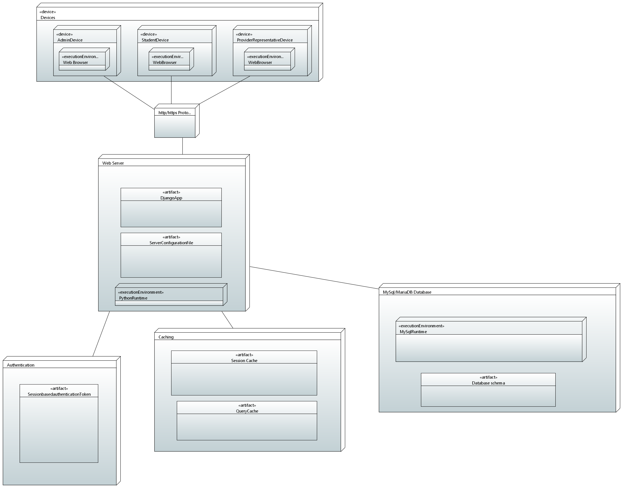

# **Design Strategy**

### **Architectural Strategy Overview**

FastTransit uses a modular, layered architecture built with the Django framework to ensure:

* Clear separation of concerns,
* Reusable logic,
* Maintainable structure,
* Scalability for future expansion (like inter-city transit or smart card integration).

### **Future System Extension / Enhancement**

* Modularity through Django apps allows plugging in new features like driver rating systems or route optimization without refactoring core logic.
* API-first design supports mobile app integration or IoT extension for real-time vehicle data.

Trade-off: Slightly more boilerplate code, but far better extensibility.

### **System Reuse**

* Reusable components include:
  + Authentication (Django’s built-in auth system),
  + Payment module (Stripe integration),
  + CRUD APIs (generic class-based views).
* Code follows DRY (Don’t Repeat Yourself) and single responsibility principles.

Trade-off: Slight complexity in isolating reusable components, mitigated by Django’s app structure.

### 

### **User Interface Paradigm**

* The UI follows a role-based interface design, where each type of user (Admin, User, Transporter) has specific dashboards.
* Built with responsive design principles to ensure accessibility on both desktop and mobile.
* Trade-off: Slight increase in frontend complexity, justified by improved UX across roles.

### **Data Management**

* Storage: MYSQL handles structured storage for users, transactions, and route data.
* Distribution: Centralized now, but DB schema supports sharding or replication for scale.
* Persistence: All point records and fare histories are persistently stored with backup/restore support.

Trade-off: Central DB can be a bottleneck in future unless optimized with indexing/caching (planned).

### **Concurrency & Synchronization**

* Stripe webhook handling is asynchronous to avoid blocking the main thread.
* Django handles per-request thread isolation; race conditions are avoided by transactional DB operations.

Trade-off: Limited real-time concurrency without async/Django Channels, but acceptable for MVP phase.

# **Detailed System Design**

### **ER Diagram**

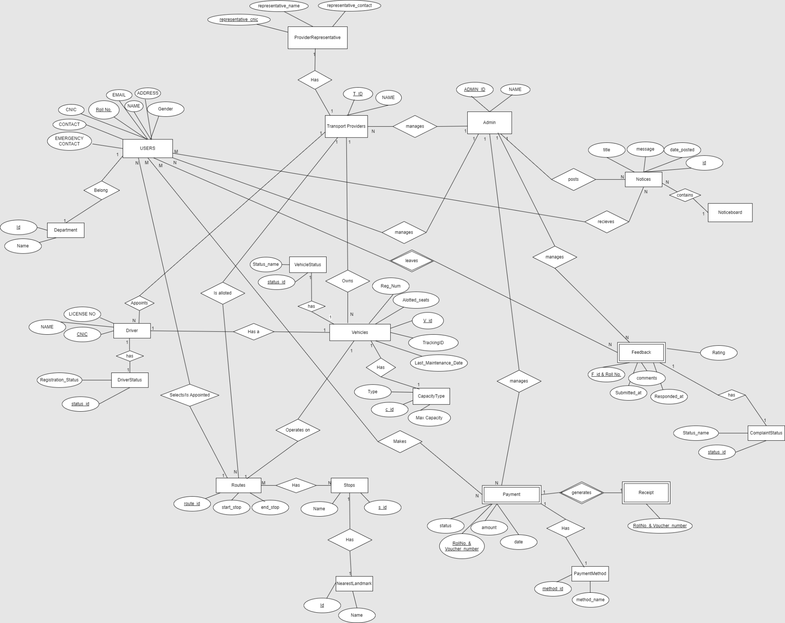

### **Data Dictionary**

#### **Data 1-Admin**

| Name | Admin |
| --- | --- |
| Alias | System Admin, Backend Operator |
| Where-used/how-used | Input to: Login Validation Process Output from: Admin Registration Process Used in: Admin Dashboard (for user/route management) |
| Content description | Admin = Admin_ID + Name + Email + Password + Role |

| Column Name | Description | Type | Length | Nullable | Default Value | Key Type |
| --- | --- | --- | --- | --- | --- | --- |
| admin_id | Unique ID for the admin | Integer | 11 | No | Auto Increment | PK |
| name | Admin's full name | Varchar | 50 | No | None |  |
| email | Admin's login email | Varchar | 100 | No | None |  |
| password | Hashed password | Varchar | 255 | No | None |  |
| role | Role of the admin (e.g., Super) | Varchar | 20 | No | 'admin' |  |

#### **Data 2-Transporter**

| Name | Transporter |
| --- | --- |
| Alias | Bus Driver, Vehicle Operator |
| Where-used/how-used | Input to: Location Tracking, Trip Status Output from: Transporter Registration Used in: Bus Assignment and Tracking Modules |
| Content description | Transporter = Transporter_ID + Name + Phone + Vehicle_ID + Assigned_Route + Status |

| Column Name | Description | Type | Length | Nullable | Default Value | Key Type |
| --- | --- | --- | --- | --- | --- | --- |
| transporter_id | Unique ID for transporter | Integer | 11 | No | Auto Increment | PK |
| name | Full name of transporter | Varchar | 50 | No | None |  |
| phone | Contact number | Varchar | 15 | No | None |  |
| vehicle_id | Assigned bus ID | Integer | 11 | No | None | FK |
| assigned_route | Route number or name | Varchar | 100 | Yes | NULL |  |
| status | Transporter availability (Active/Idle) | Varchar | 20 | No | 'Idle' |  |

#### **Data 3-User**

| Name | User |
| --- | --- |
| Alias | Passenger, App User, Commuter |
| Where-used/how-used | Input to: Booking and Fare Calculation Process Output from: User Registration Process Used in: Point Management, Payment, Voucher Generation |
| Content description | User = User_ID + Name + Email + Password + Point_Balance + Point_ID + Role |

| Column Name | Description | Type | Length | Nullable | Default Value | Key Type |
| --- | --- | --- | --- | --- | --- | --- |
| user_id | Unique ID for the user | Integer | 11 | No | Auto Increment | PK |
| name | Full name of the user | Varchar | 50 | No | None |  |
| email | User's email for login | Varchar | 100 | No | None |  |
| password | Hashed password | Varchar | 255 | No | None |  |
| point_balance | Available points in the wallet | Integer | 10 | No | 0 |  |
| point_id | Unique Point Card ID | Varchar | 20 | Yes | NULL |  |
| role | 'user' / 'admin' / 'transporter' | Varchar | 20 | No | 'user' |  |

|  |  |  |
| --- | --- | --- |

## **Application Design**

### **5.2.1 Sequence Diagram**

#### **Admin Sequence Diagram**

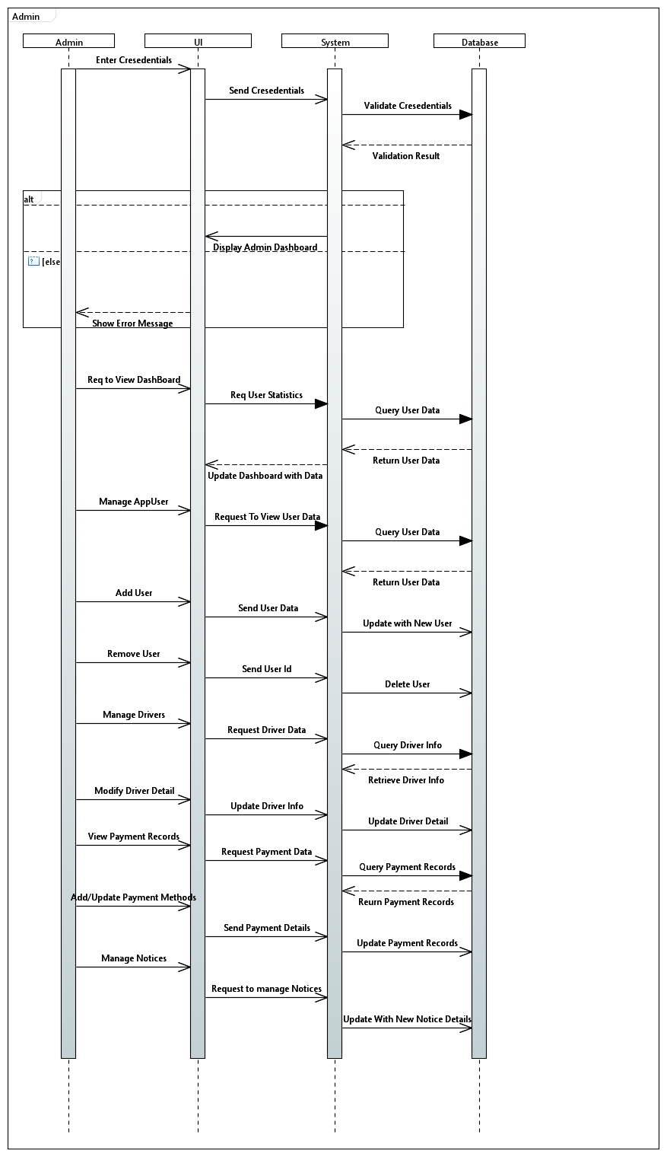

#### **App User Sequence Diagram**

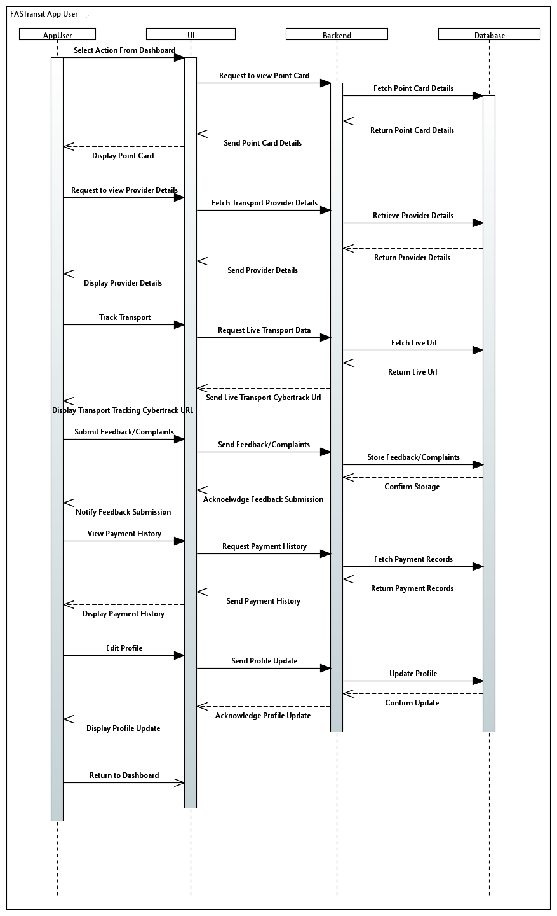

#### **Login Sequence Diagram**

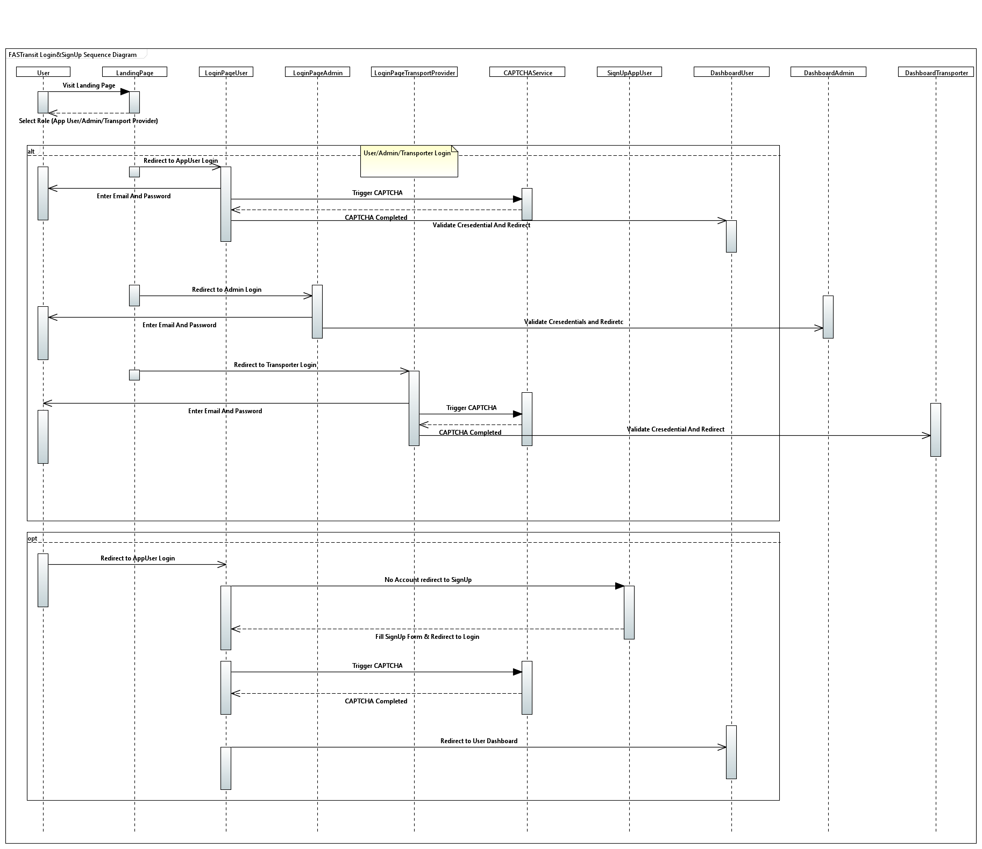

#### **Transporter Sequence Diagram**

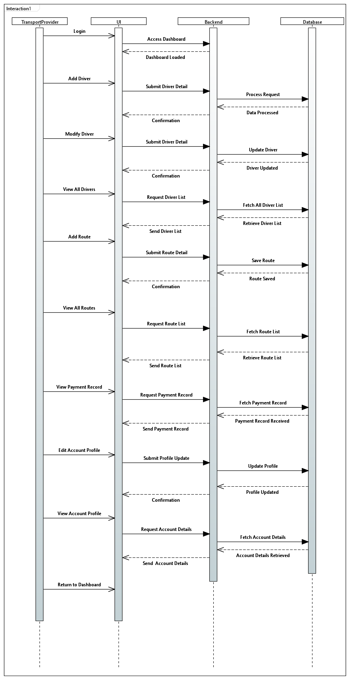

### **State Diagram**

### 

# **References**

1. **Django Project Documentation**  
   Title: **Django 4.2 Documentation**  
   Publisher: Django Software Foundation  
   URL: <https://docs.djangoproject.com/en/4.2/>
2. **Stripe API Reference**  
   Title: **Stripe API Documentation**  
   Publisher: Stripe, Inc.  
   URL: <https://stripe.com/docs/api>  
   Accessed: 2025
3. **Python Official Docs**  
   Title: **Python 3.11 Documentation**  
   Publisher: Python Software Foundation  
   URL: <https://docs.python.org/3/>
4. **FAST NUCES Software Engineering Guidelines**  
   Title: **SDS & SRS Manual for Capstone Projects**  
   Publisher: FAST School of Computing – Karachi Campus  
   Year: 2024  
   Access: University Internal Portal
5. **MySQL Reference Manual**  
   Title: **MySQL 8.0 Documentation**  
   Publisher: Oracle Corporation  
   URL: <https://dev.mysql.com/doc/>
6. **UML Distilled: A Brief Guide to the Standard Object Modeling Language**  
   Author: Martin Fowler  
   Publisher: Addison-Wesley  
   Edition: 3rd Edition  
   Year: 2004

# **Appendices**

### **Appendix A: Supporting Details for FastTransit System**

1. **Database Schema**
   * The database schema for the FastTransit system includes tables for users, transports, payment_transactions, points, vouchers, etc. Each table is linked to ensure referential integrity across the system.

Example:

* + users table: Stores user details like user ID, name, email, and point balance.
  + payment_transactions table: Contains transaction details with reference to user ID, payment amount, and status.

1. **Payment Gateway Integration (Stripe)**
   * For payments, **Stripe** has been integrated to allow users to pay the fare securely. This involves API calls to Stripe's servers to handle payment processing.
   * The PaymentHandler class abstracts the communication with Stripe, ensuring that users' sensitive information is never stored locally, and payment data is securely processed.
2. **System Architecture Diagrams**
   * A detailed architecture diagram can be found below, showing the relationships between theAdmin**,** User, and Transporter modules.
   * Additional diagrams illustrating key workflows (e.g., User selects a bus, Stripe payment integration, etc.) can be provided to ensure clarity in understanding the system flow.
3. **User Interface Mockups**
   * The mockups for the FastTransit user interface are attached, showing the User dashboard, payment screens, bus tracking pages, and voucher generation.
4. **Error Handling Strategies**
   * FastTransit implements specific error handling for edge cases like invalid payment information, incorrect point balance, or unavailable buses. Below is an example of error handling for Stripe payment failures:
5. **Code Quality Standards**
   * The system follows Python's PEP 8 coding standards, with additional guidelines specific to FastTransit (e.g., naming conventions, commenting practices, etc.). Unit tests are written for critical components, especially payment processing and bus tracking functionality.
6. **Security Measures**
   * To prevent unauthorized access, FastTransit uses OAuth2 for secure user authentication. Furthermore, all payment transactions are encrypted using SSL certificates, ensuring secure communication between users and payment servers.
7. **Data Privacy and Compliance**
   * FastTransit complies with data privacy regulations, including GDPR, ensuring that user data (such as personal information and payment details) is stored securely and only accessible by authorized personnel.
8. **Performance Considerations**
   * Performance benchmarks show that the system can handle 1000 concurrent users, with minimal latency during bus tracking and payment processing.